The TARDIS Project Demonstration

Sprint 1

1. Discuss ConsoleUtil class.
2. Models
   1. Character.cs
      1. Enum RaceType
      2. 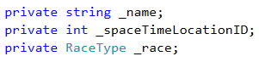
      3. Add Constructor with 3 parameters
   2. SpaceTimeLocations.cs
      1. 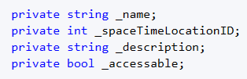
   3. Traveler.cs
      1. Add Constructor with 3 parameters and reference to base class

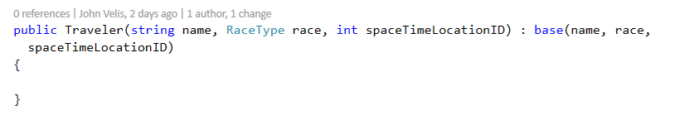

* 1. TravelerAction.cs
     1. Explore
  2. Universe.cs
     1. Add list of SpaceTimeLocations with auto implemented property
     2. Add constructor and initialize the list
     3. Note GetSpaceTimeLocationByID() method

1. Controller
   1. Note bool fields: _usingGame and _missionInitialized
   2. Add objects fields

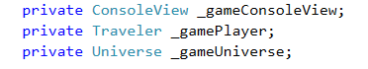

* 1. Complete the constructor

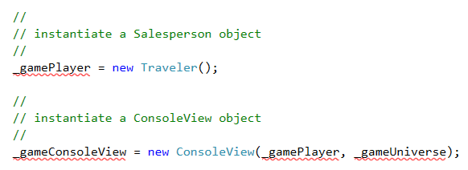

* 1. Complete InitializeGame

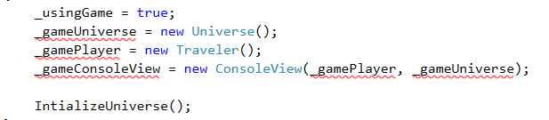

* 1. Explore InitializeUniverse() method
  2. Explore ManageGameLoop and DisplayGetTravelerActionChoice
  3. InitializeMission
     1. DisplayMissionSetupIntro()
     2. DisplayGetTravelersName()
     3. DisplayGetTravelersRace()
     4. DisplayGetTravelersNewDestination()
        1. Universe.GetSpaceTimeLocationByID
           1. Exception thrown

1. ConsoleView
   1. Add object fields



* 1. Initialize object fields in constructor
  2. DisplayTravelerInfo()

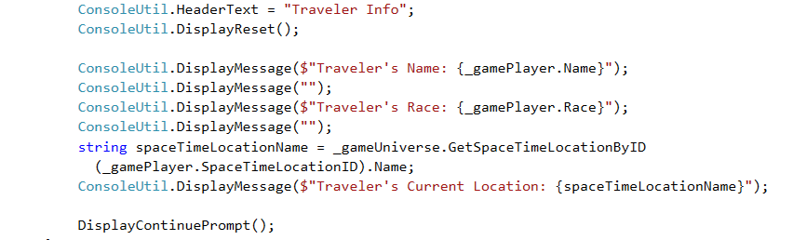

* 1. DisplayListAllTARDISDestinations()
  2. DisplayLookAround()



* 1. nn